AVERAGES FROM FREQUENCY TABLES
Pearson Edexcel - Tuesday 19 May 2020 - Paper 1 (Non-Calculator) Foundation Tier

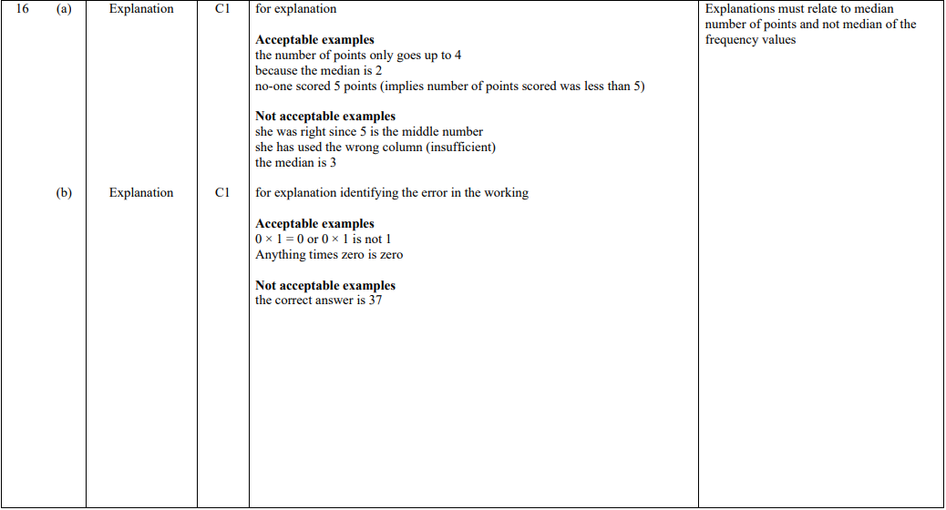

Pearson Edexcel - Tuesday 11 June 2019 - Paper 3 (Calculator) Foundation Tier

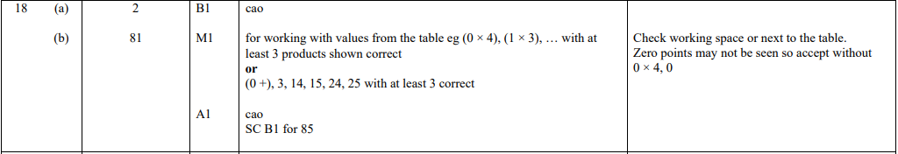

Pearson Edexcel - Monday 12 November 2018 - Paper 3 (Calculator) Foundation Tier

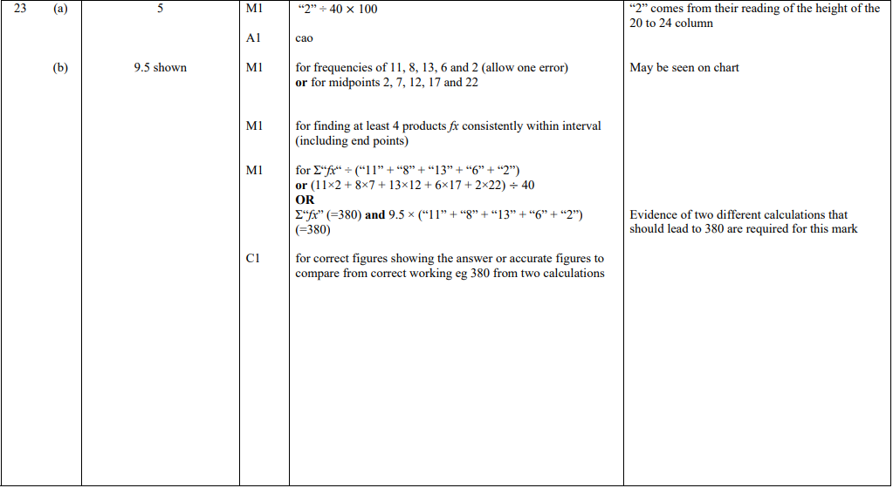

Pearson Edexcel - Thursday 7 June 2018 - Paper 2 (Calculator) Foundation Tier

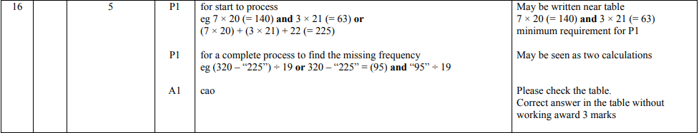

Pearson Edexcel - Thursday 2 November 2017 - Paper 1 (Non-Calculator) Foundation Tier

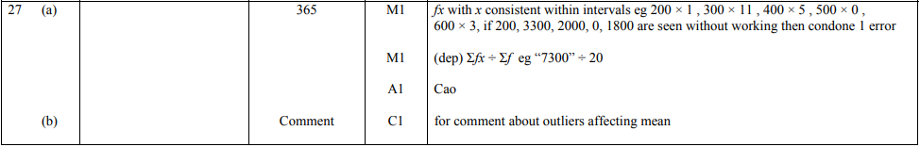

Pearson Edexcel - Wednesday 8 November 2017 - Paper 3 (Non-Calculator) Foundation Tier

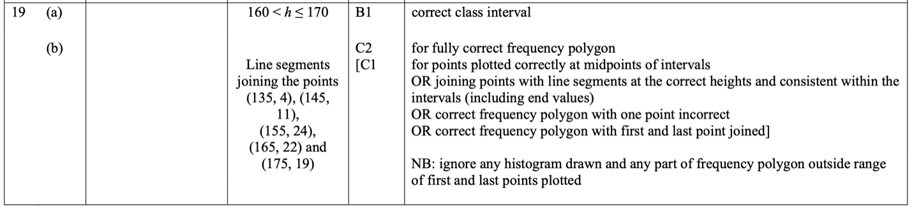

Pearson Edexcel – Specimen 2 - Paper 1 (Non-Calculator) Foundation Tier

Pearson Edexcel – Specimen 2 - Paper 2 (Calculator) Foundation Tier

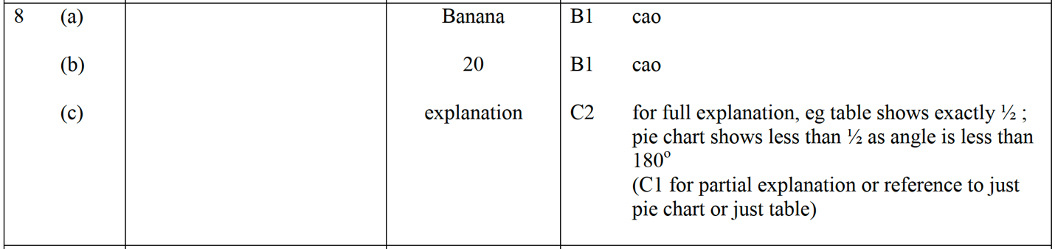

Pearson Edexcel – Specimen 2 - Paper 3 (Calculator) Foundation Tier

Pearson Edexcel – Specimen 1 - Paper 2 (Calculator) Foundation Tier

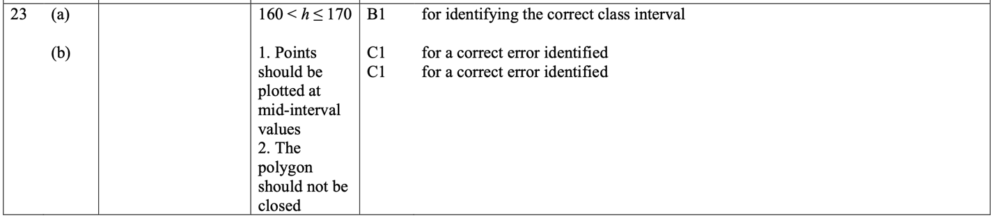

Pearson Edexcel – Specimen 1 - Paper 3 (Calculator) Foundation Tier

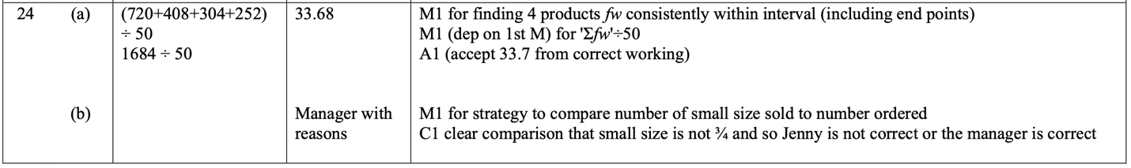

OCR Tuesday 21 May 2019 – Morning (Calculator) Foundation Tier
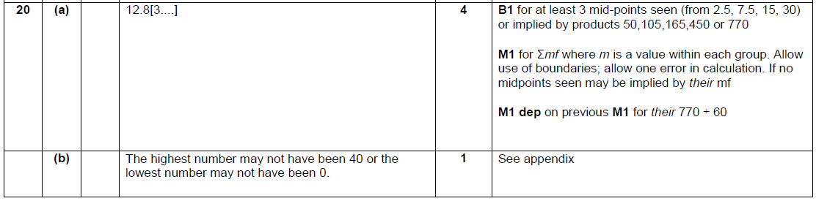

OCR Monday 24 May 2018 – Morning (Calculator) Foundation Tier

Pearson Edexcel – Sample Papers - Paper 1 (Non-Calculator) Foundation Tier

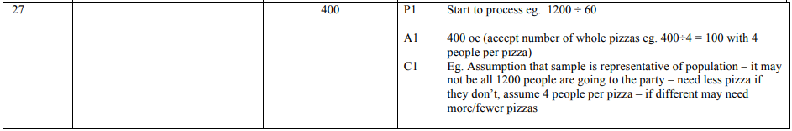
Pearson Edexcel –Sample Papers - Paper 2 (Calculator) Foundation Tier

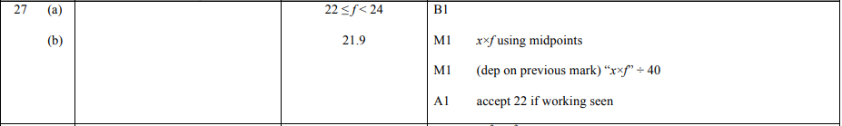
OCR Wednesday 8 November 2017– Morning (Calculator) Foundation Tier

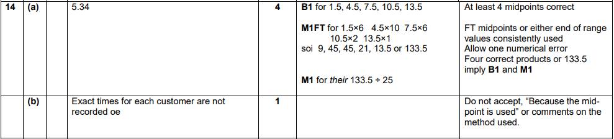
OCR Sample Question Paper 3 – Morning/Afternoon (Calculator) Foundation Tier

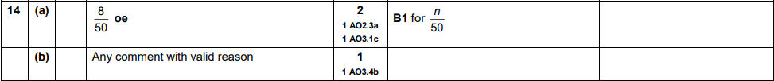
AQA Thursday 4 June 2020 – Morning (Calculator) Foundation Tier

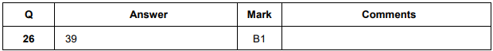

AQA Tuesday 21 May 2019 – Morning (Non-Calculator) Foundation Tier

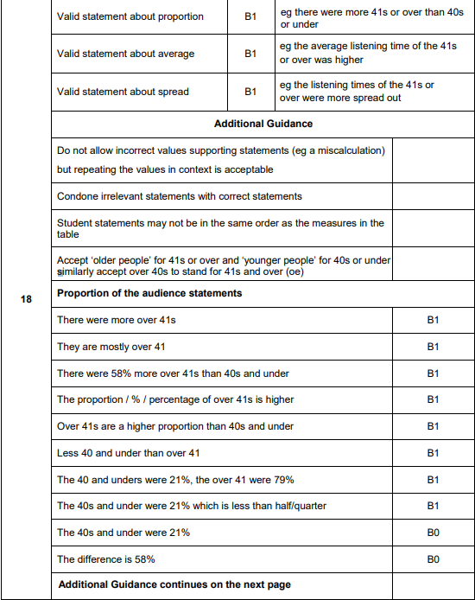
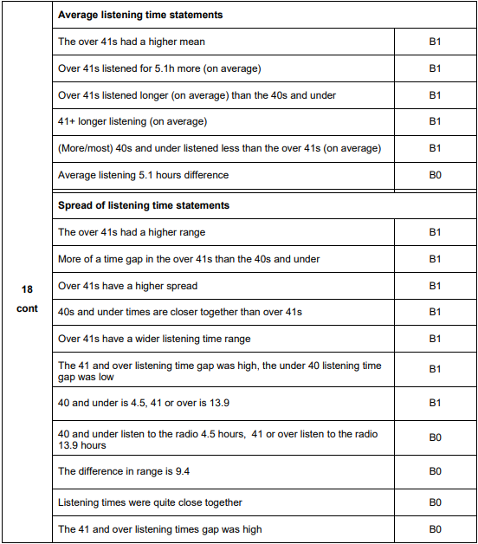

AQA Thursday 6 June 2019 – Morning (Calculator) Foundation Tier

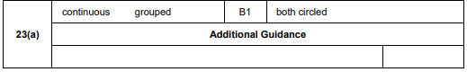
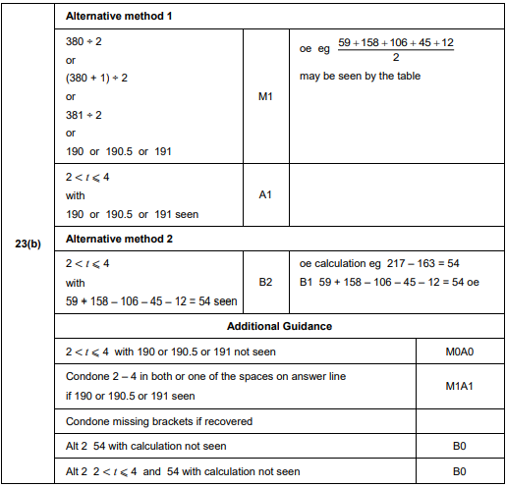
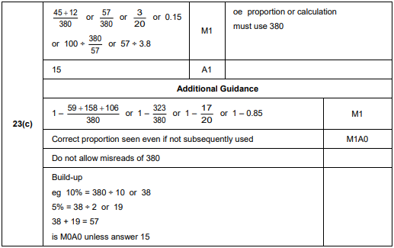

AQA Tuesday 6 November 2018 – Morning (Non-Calculator) Foundation Tier

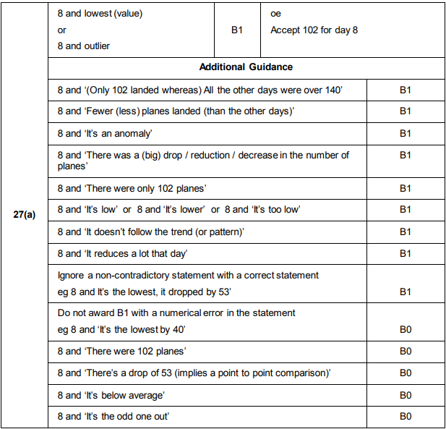

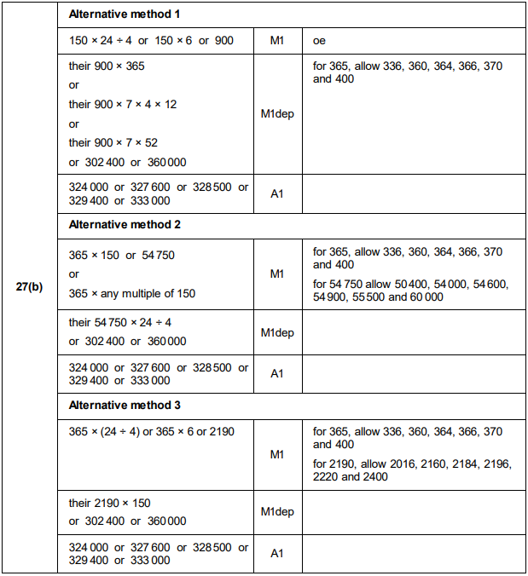
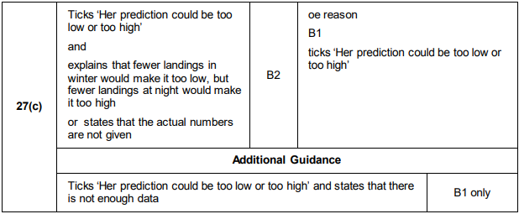
AQA Thursday 8 November 2018 – Morning (Calculator) Foundation Tier

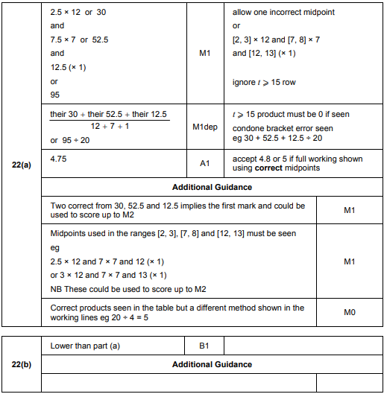
AQA Thursday 7 June 2018 – Morning (Calculator) Foundation Tier

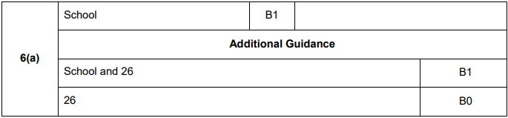
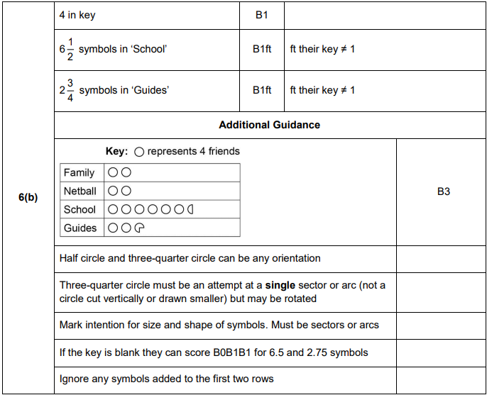

AQA Monday 6 November 2017 – Morning (Calculator) Foundation Tier

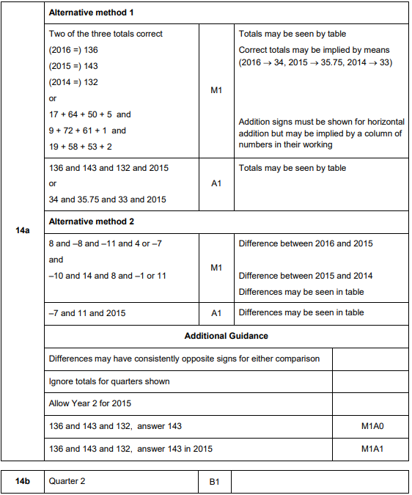

AQA Wednesday 8 November 2017 – Morning (Calculator) Foundation Tier

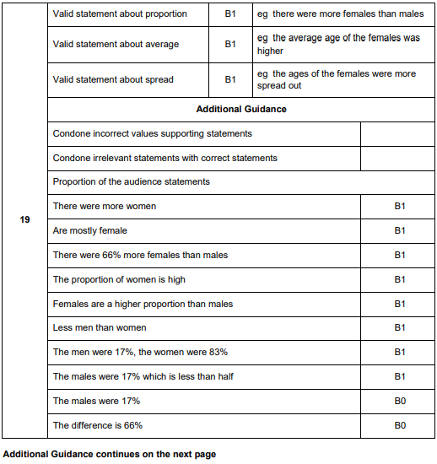
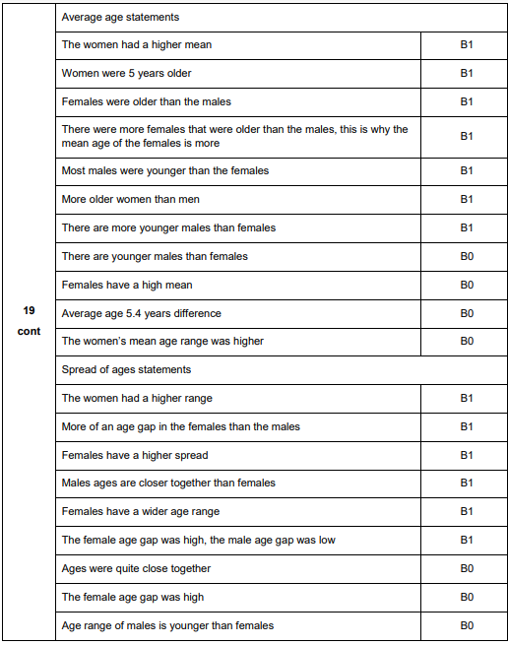

AQA Thursday 25 May 2017– Morning (Non-Calculator) Foundation Tier

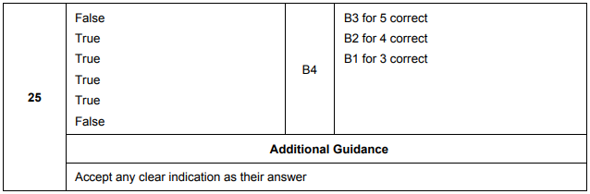
AQA Sample Paper 3– Morning (Calculator) Foundation Tier

